SMI2-M. Using Spy Mode

1. Introduction
The example discusses setting up the exchange of the SMI2-M indicator in Spy mode. In this mode, the indicator listens to the bus, waiting for a request with the specified parameters. This allows indicators to be integrated into systems where a network master is already present, which cannot be reconfigured to poll another slave device.
As an example, consider the case when the programmable relay PR102 is connected to cloud service OwenCloud using the network gateway of the Px210 line. Suppose one from the values ​​read by OwenCloud must also be displayed on the SMI2-M indicator. In this situation, SMI2-M cannot be used in network master mode, since the master is already OwenCloud, and within the RS-485 bus there can only be one master. That's why SMI2-M is used in a special Spy mode.
Table 1. Device network settings
Parameter | Cloud | PR102 | SMI2-M
Interface | RS-485 | RS-485-1 | RS-485
Protocol | Modbus RTU
Operating mode | Master | Slave | Spy
Address | - | 16 | -
Baud rate | 115200
Number of data bits | 8
Parity | -
Stop bit | 1

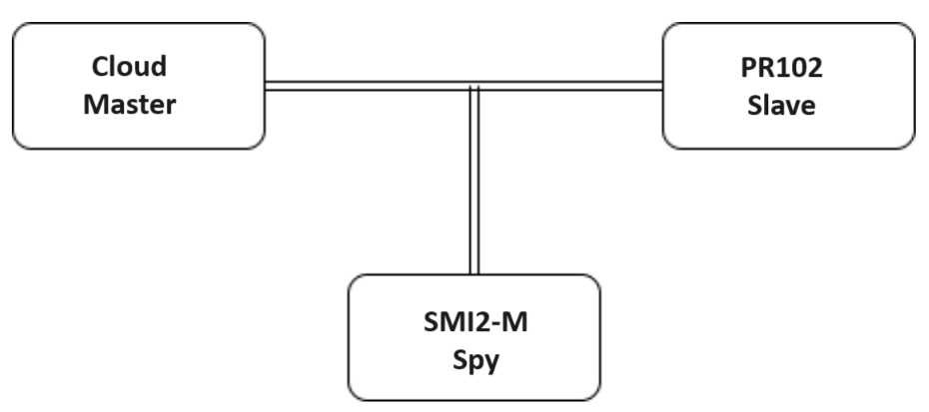
Picture 1. Example block diagram

2. Setting up PR102
Create a project in OwenLogic for the desired PR model. Go to menu Device – Settings device. On the Interfaces/RS-485 tab, set the PR network settings in accordance with table. 1
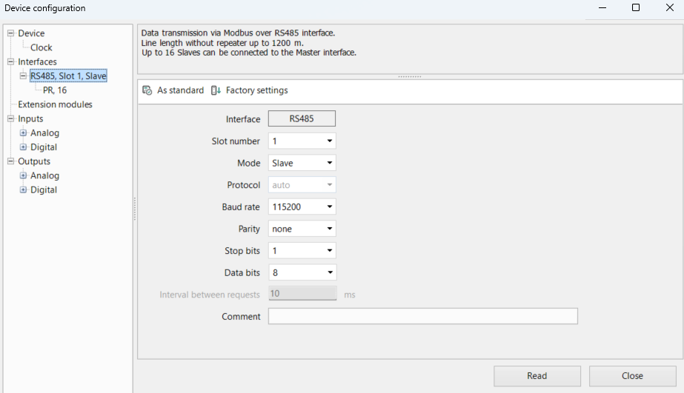
Picture 2 Adding a PR interface in Modbus Slave mode
In the slave device node, specify the address (in accordance with Table 1 – 16) and add a channel with address 512 floating point type. Declare a network variable rValue in the channel.
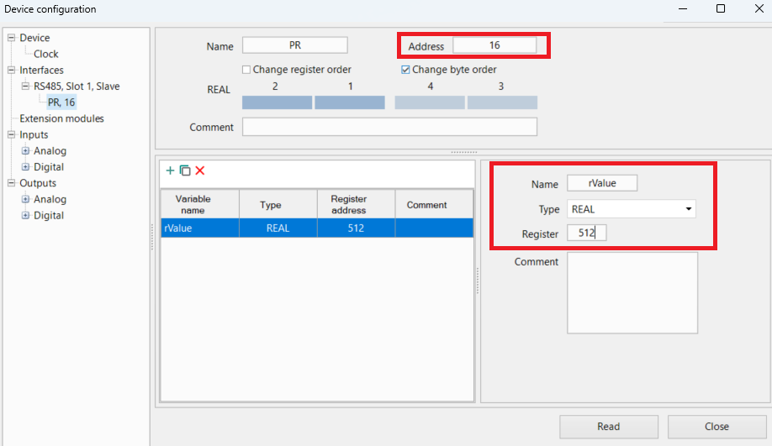
Picture 3 Slave channel settings

Assign the rValue variable to the first analog input in the program. Set up analog input can be found on the Inputs/Analog tab.
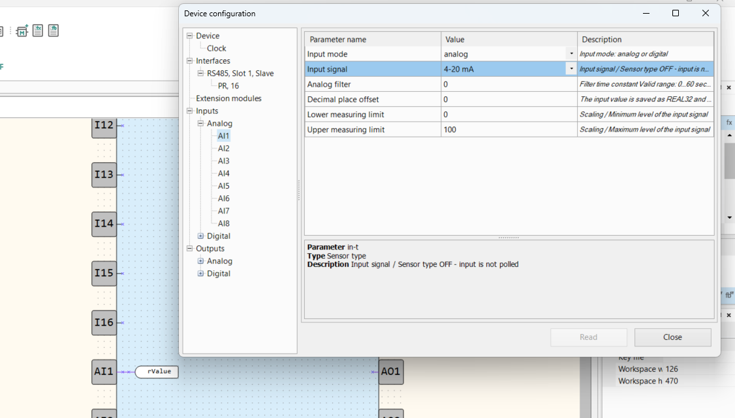
Picture 4. Analog input settings

3. Setting up OwenCloud
This example does not describe adding PR102 to the OwenCloud cloud service. Relevant information is provided in the OM for the network gateway and OM to OwenCloud. Note only that when adding a device you need to specify its network settings and address in according to table. 1.
One parameter has been added for the device - in accordance with paragraph 2, it has address 512 (i.e. 0x200 - Please note that in OwenCloud register addresses are specified in HEX) and the type is float (with floating point). Also, to display the parameter correctly, you should set Check the Register order: low register first.
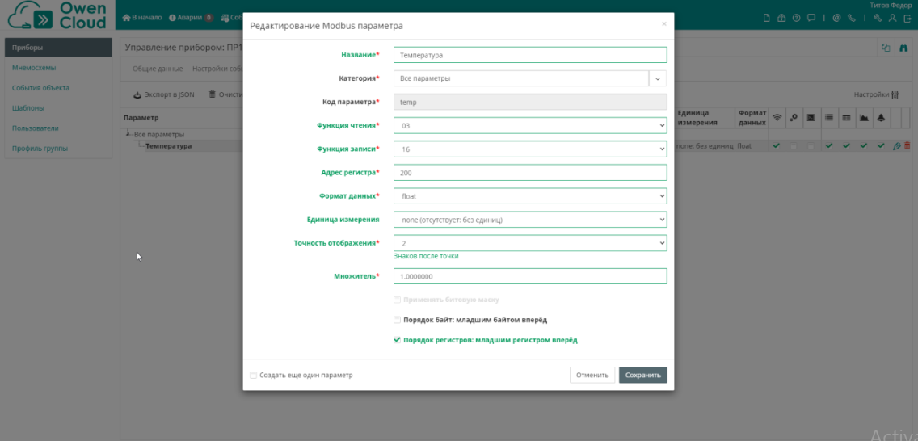
Picture 5 OwenCloud parameter settings

4. Setting up SMI2-M
Configuration of SMI2-M is carried out through the ARIES Configurator software. To configure the indicator needs to be connected to a PC using a MicroUSB/USB cable. Launch ARIES Configurator and Click the Add device button. Specify the number of the virtual COM port (it can be find out in Windows Device Manager), Owen Auto Detection Protocol, mode connection settings Auto and address 1. Click the Find button, then the Add button device.
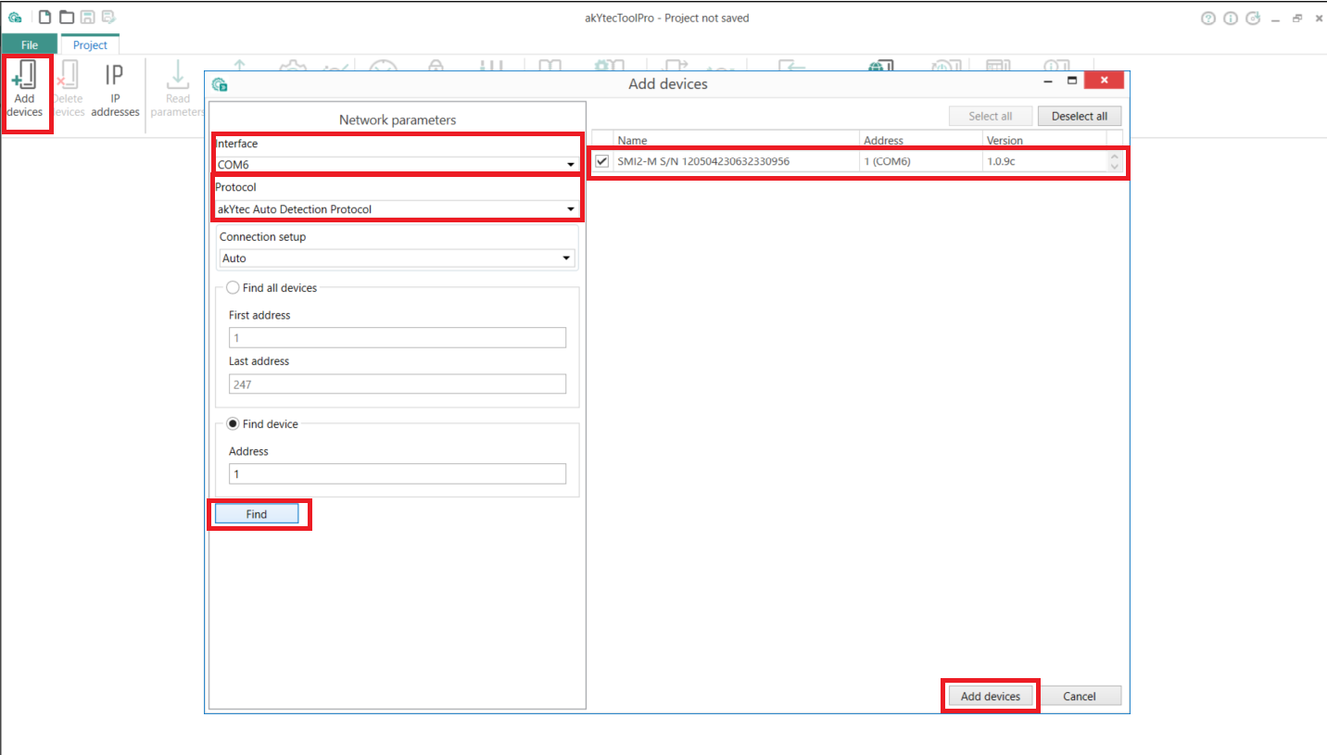
Picture 6. Connection to SMI2-M in ARIES Configurator
In the RS-485 Settings tab, set the network parameters in accordance with the table. 1. On the tab Indicator set the indicator operation mode using the Modbus protocol – Spy. On the tab Indicator/Settings Modbus Spy specify the parameters of the request that SMI2-M will expect:
• device address = 16 (according to Table 1);
• function code = 0x03 (according to Picture. 5);
• register address = 512 (according to Picture. 3).
On the Indicator/Indicator Settings tab, specify the REAL type. Also you can configure decimal point position and other parameters.
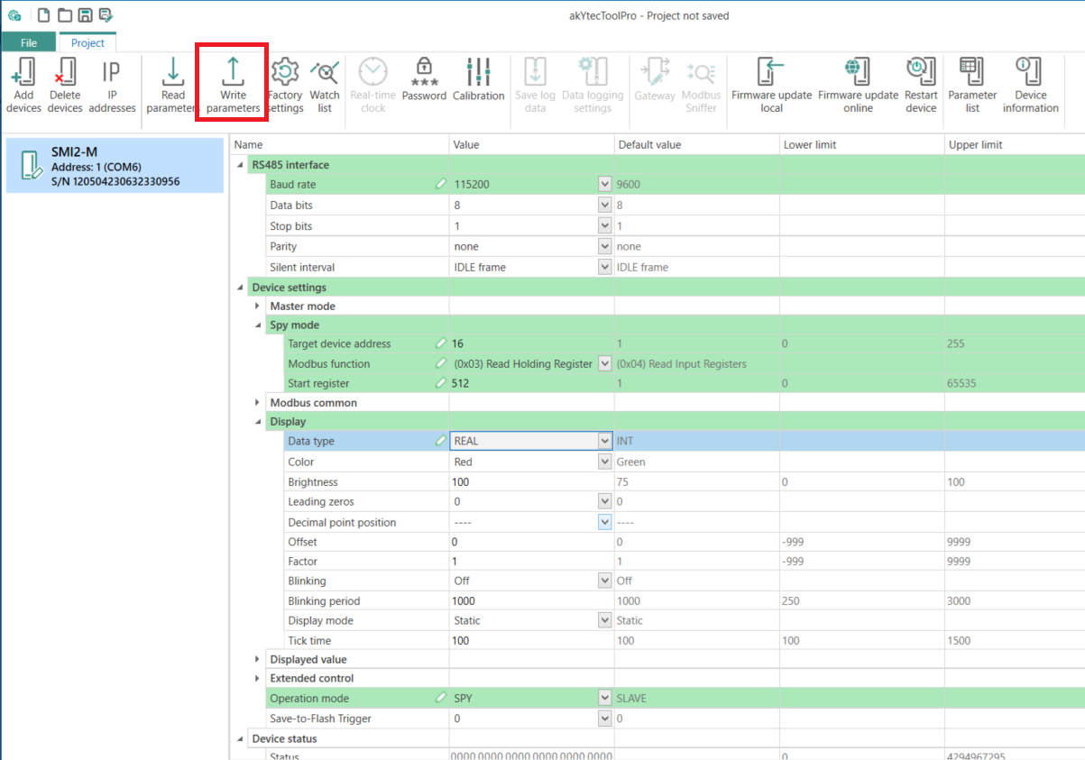
Picture. 7. SMI2-M settings
Click the Write parameters ​​button to write the settings to the device.

5. Working with an example
Connect the devices and supply power to them. Load the project into PR102 and make sure that The switch on the device body is in the Run position.
The value of the first analog input will be displayed in OwenCloud and on SMI2-M.

